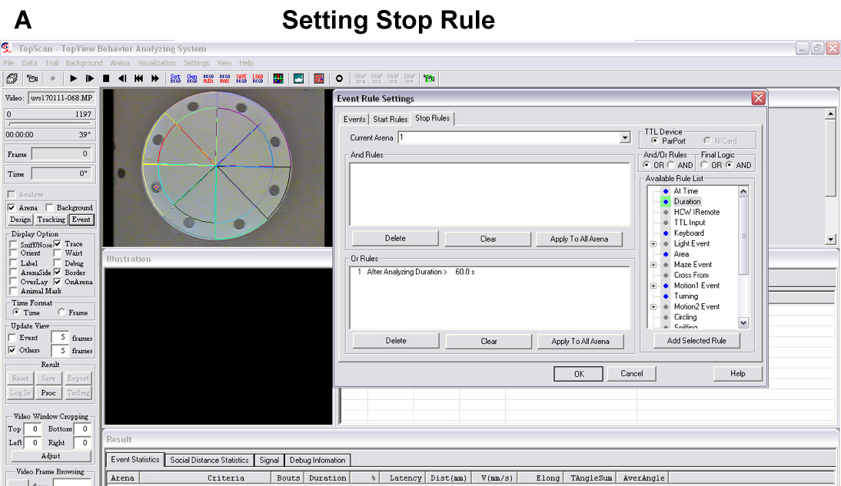
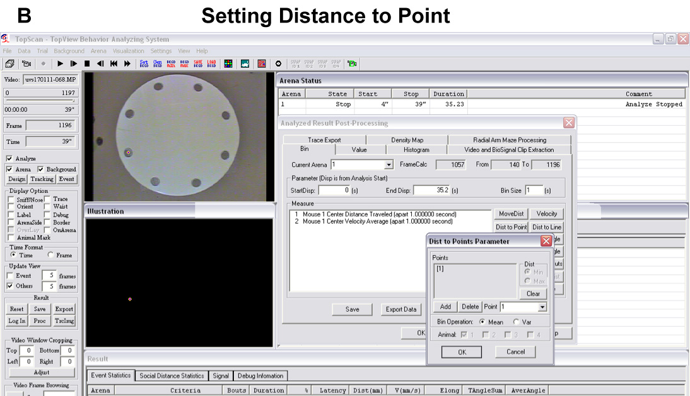
Figure S2. Data analysis. A. Screenshot of setting stop rules using the ‘Event’ button. B. Screenshot of setting ‘distance to point’ for data export after video analysis.

